## Week:01-01

Q1)ProblemStatement:

This is a simple challenge to help you practice printing to stdout. We're starting out by printingthemostfamouscomputingphraseofalltime!Intheeditorbelow,useeitherprintf or cout to print the string Hello, World! to stdout.

InputFormat

Youdonotneedto readanyinputinthischallenge.

## OutputFormat

PrintHello,World!tostdout. Sample Output 1

Hello,World!

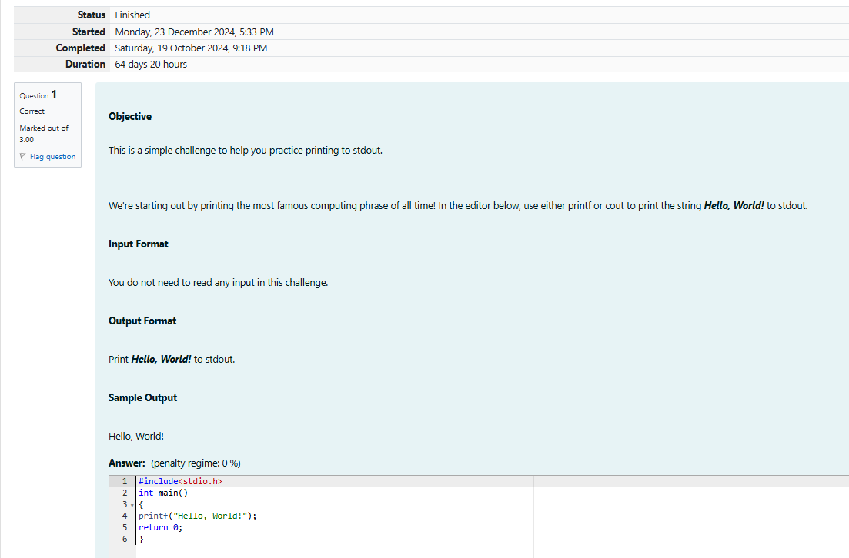

# OUTPUT:

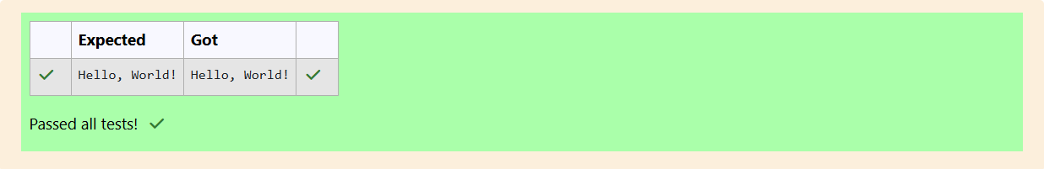

Q2)Thischallengewillhelpyoutolearnhowtotakeacharacter,astringandasentenceasinputin

C.Totakeasinglecharacterchasinput,youcanusescanf("%c",&ch);andprintf("%c",ch)writesa character specified by the argument char to stdout:

charch;

scanf("%c",&ch);

printf("%c",ch);

## SampleInput1

C

program

ProgrammingusingC

## SampleOutput1

C

program

ProgrammingusingC

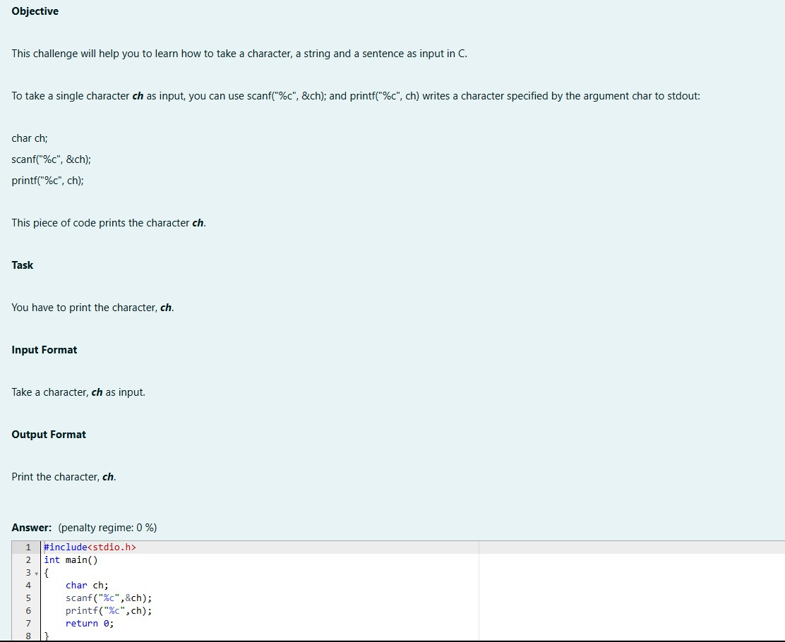

# OUTPUT:

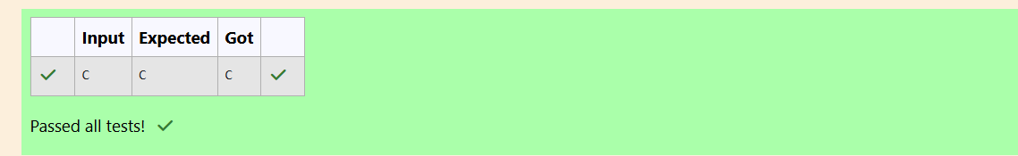

### Q3)ProblemStatement:

Thefundamentaldatatypesincareint,floatandchar.Today,we'rediscussingintandfloatdata types.

Theprintf()functionprintsthegivenstatementtotheconsole.Thesyntaxisprintf("formatstring", argument_list);. In the function, if we are using an integer, character, string or float as argument, then in the format string we have to write %d (integer), %c (character), %s (string), %f (float) respectively.

Thescanf()functionreadstheinputdatafromtheconsole.Thesyntaxisscanf("formatstring", argument_list);. For ex: The scanf("%d", &number) statement reads integer number from the

consoleandstoresthegivenvalueinvariablenumber.Toinputtwointegersseparatedbyaspaceon a single line, the command is scanf("%d %d", &n, &m), where n and m are the two integers.

Task

Yourtaskistotaketwonumbersofintdatatype,twonumbersoffloatdatatypeasinputand output their sum:

Declare4variables:twooftypeintandtwooftypefloat.

Read2linesofinputfromstdin(accordingtothesequencegiveninthe'InputFormat'section below) and initialize your 4 variables.

Usethe+and-operatortoperformthefollowingoperations:

Printthesumanddifferenceoftwointvariableonanew line.

Printthesumanddifferenceoftwofloatvariableroundedtoonedecimalplaceonanewline.

## InputFormat

Thefirstlinecontainstwointegers.

Thesecondlinecontainstwofloatingpointnumbers. Constraints: 1 ≤ integer variables ≤ 10^4

1≤floatvariables≤ 10^4

## OutputFormat

Printthesumanddifferenceofbothintegersseparatedbyaspaceonthefirstline,andthesumand difference of both float (scaled to 1 decimal place) separated by a space on the second line.

## SampleInput

104

4.02.0

## SampleOutput

146

6.02.0

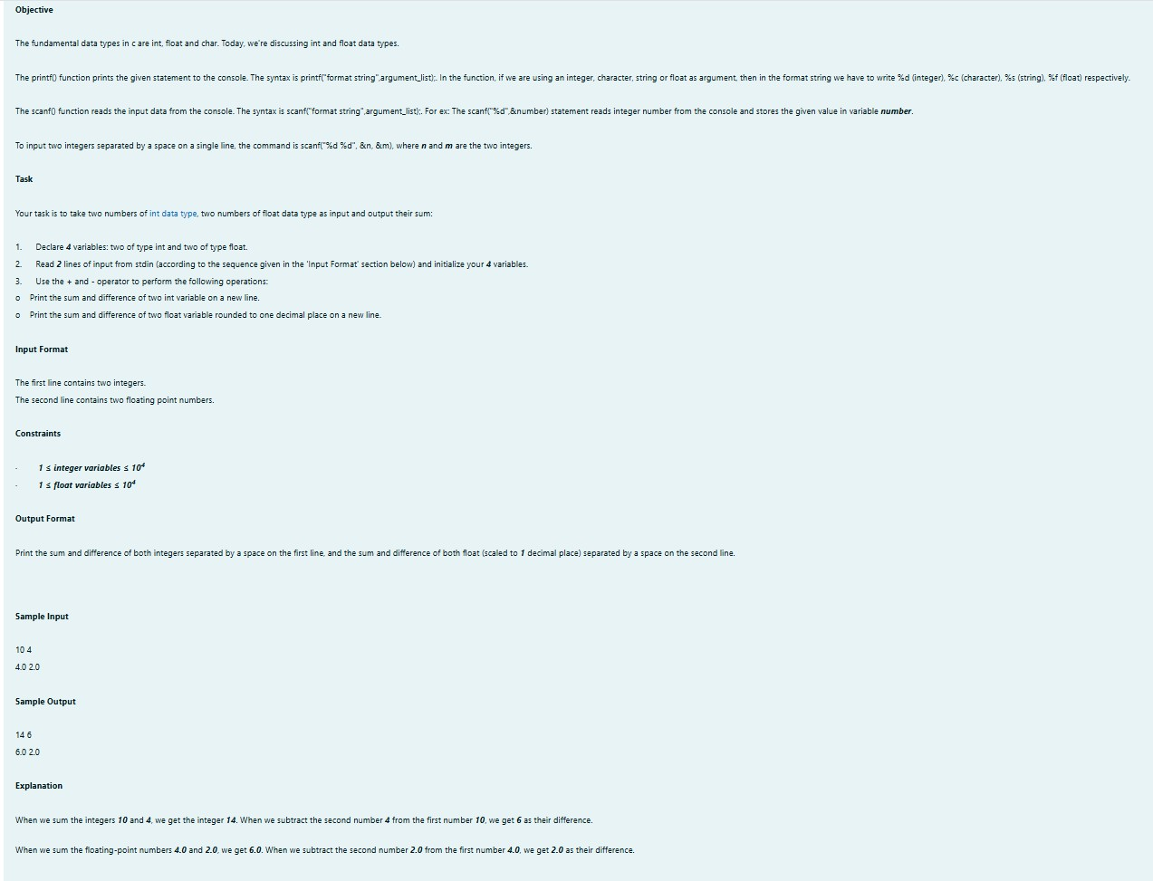

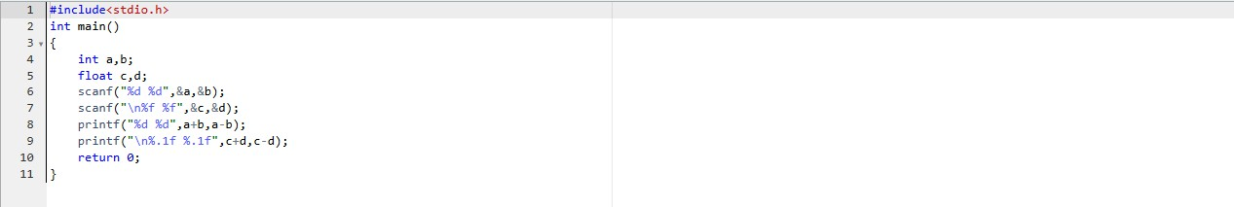

OUTPUT:

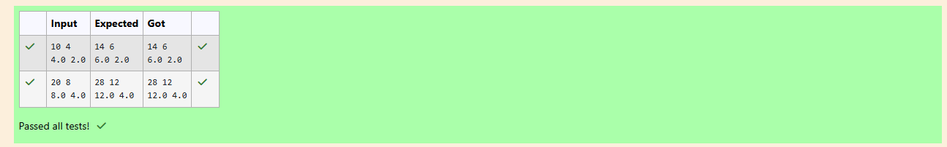

## Week:01-02

### Q1)ProblemStatement

Write aprogramtoinputaname(asasinglecharacter)andmarksofthreetestsasm1,m2,andm3 of a student considering all the three marks have been given in integer format.

Now,youneedtocalculatetheaverageofthegivenmarksandprintitalongwiththenameas mentioned in the output format section.

Allthetestmarksareinintegersandhencecalculatetheaverageinintegeraswell.Thatis,youneed to print the integer part of the average only and neglect the decimal part.

### InputFormat:

Line1:Name(Single character)

Line2:Marksscoredinthe3testsseparatedbysinglespace.

### OutputFormat:

Firstlineofoutputprintsthenameofthestudent.Secondlineoftheoutputprintstheaverage mark.

### Constraints

Marksforeachstudentlieintherange0to100(both inclusive)

### SampleInput1:

A

3 46

### SampleOutput1:

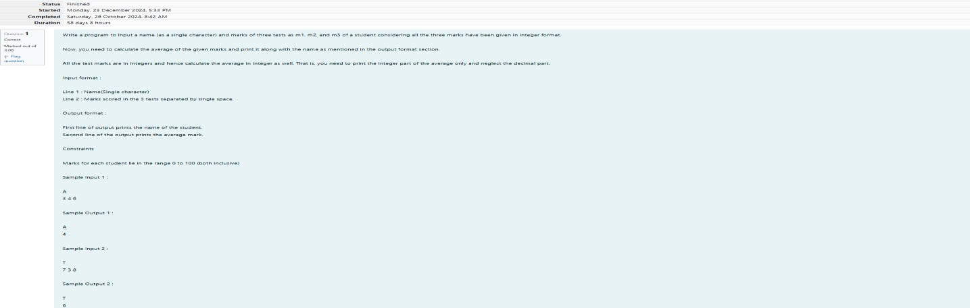A4

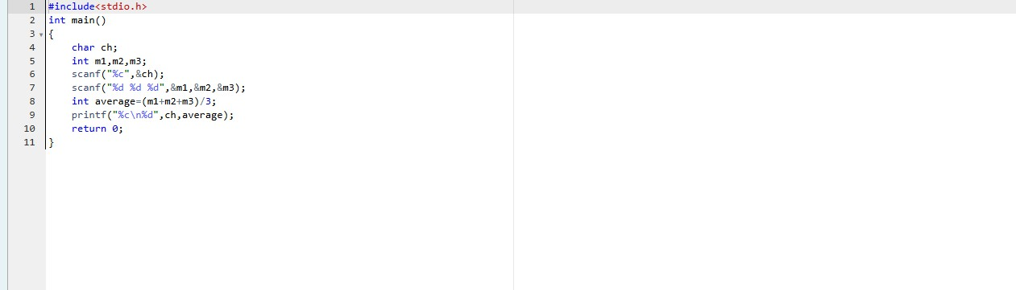

# OUTPUT:

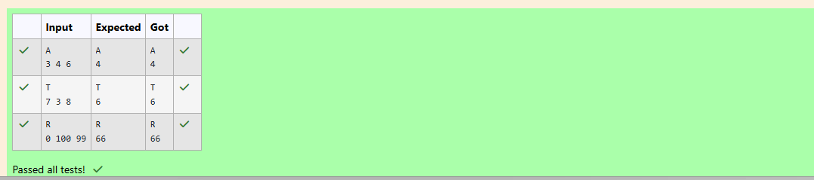

### Q2)ProblemStatement:

SomeCdatatypes,theirformatspecifiers,andtheirmostcommonbitwidthsareasfollows: Int ("%d"): 32 Bit integer

Long ("%ld"): 64 bit integer Char ("%c"): Character type Float("%f"):32bitrealvalue

Double("%lf"):64bitrealvalue

### Reading

Toreadadatatype,usethefollowingsyntax:

scanf("format_specifier",&val)

Forexample,toreadacharacterfollowedbyadouble: C

char ch; doubled;

scanf("%c%lf",&ch,&d);

Forthemoment,wecanignorethespacingbetweenformatspecifiers. Printing

Toprintadatatype,usethefollowingsyntax:

printf("format_specifier",val)

Forexample,toprintacharacterfollowedbyadouble:

C

charch= 'd';

double d = 234.432; printf("%c%lf",ch,d);

Note:Youcanalsousecinandcout insteadofscanfandprintf;however,ifyouaretakingamillion numbers as input and printing a million lines, it is faster to use scanf and printf.

### InputFormat

Inputconsistsofthefollowingspace-separatedvalues:int,long,char,float,anddouble, respectively.

### OutputFormat

Printeachelementonanew lineinthesameorderitwasreceivedasinput.Notethatthefloating- point value should be correct up to 3 decimal places and the double to 9 decimal places.

### SampleInput

3

12345678912345

a

334.23

14049.30493

### SampleOutput

3

12345678912345

a

334.230

14049.304930000

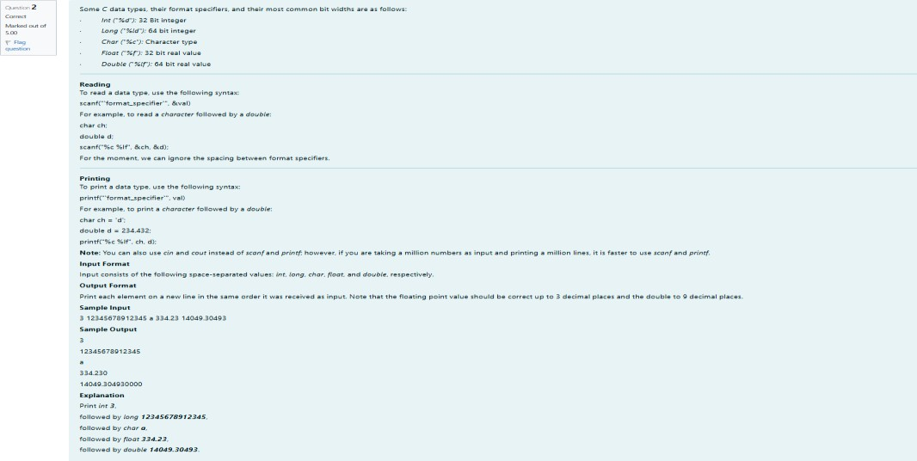

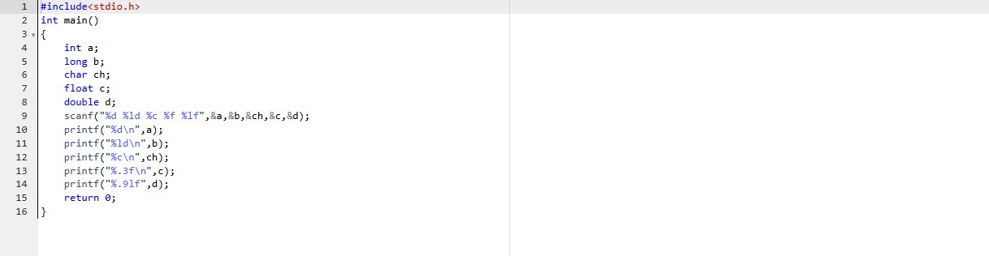

### OUTPUT:

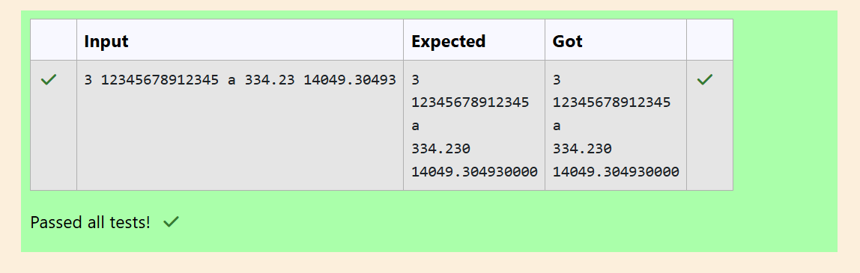

Q3)ProblemStatement:

WriteaprogramtoprinttheASCIIvalueandthetwoadjacentcharactersofthegivencharacter. Input Format: Reads the character

OutputFormat:Firstlineprintstheasciivalue,secondlineprintsthepreviouscharacterandnext character of the input character

### SampleInput1:

E

### SampleOutput1:

69

DF

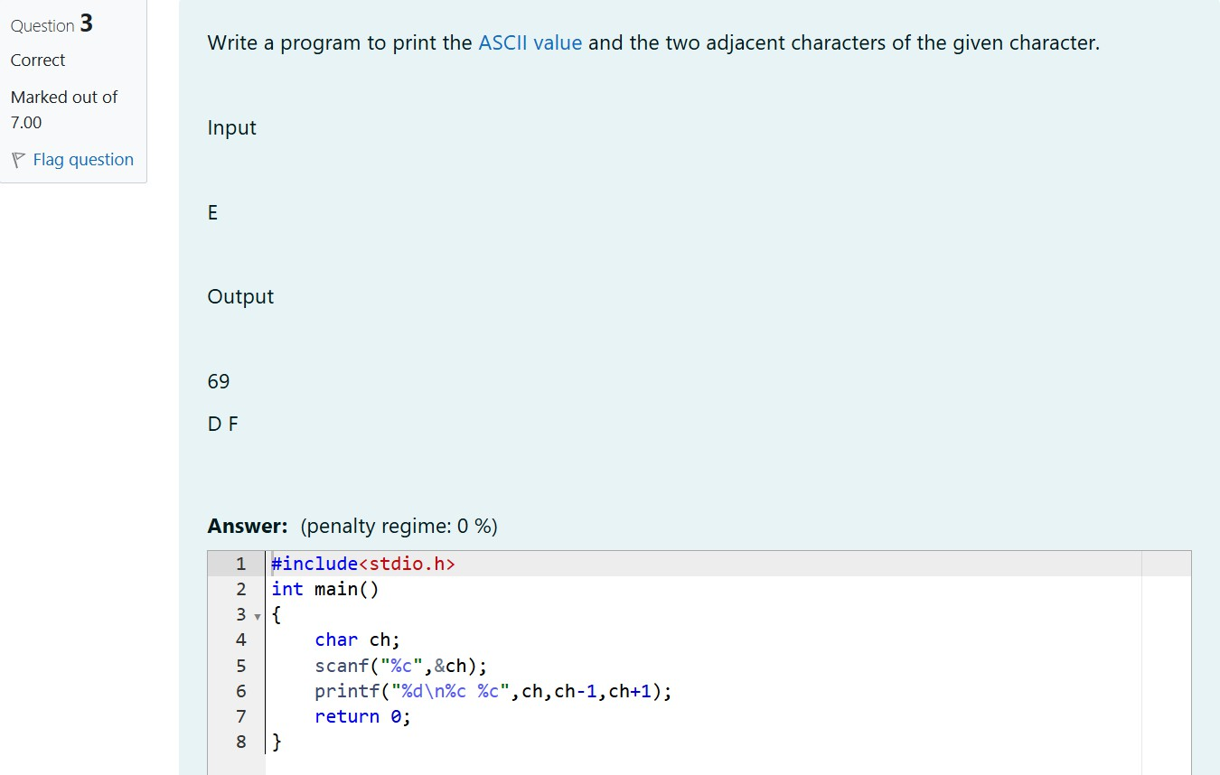

OUTPUT:

